***6 Easy Steps to Competitions***

**1. Submit Entry Form and Fees**

**2. Receive Symbol to Use**

**3. Record Routines with Symbol (Label each video with Participant Name)**

**4. Submit Video’s via our Online System**

**5. Receive Results (within 14 days**) 6. Receive Certificates / Rewards**

Virtual Competition Pack

May 2023 – Feb 2024

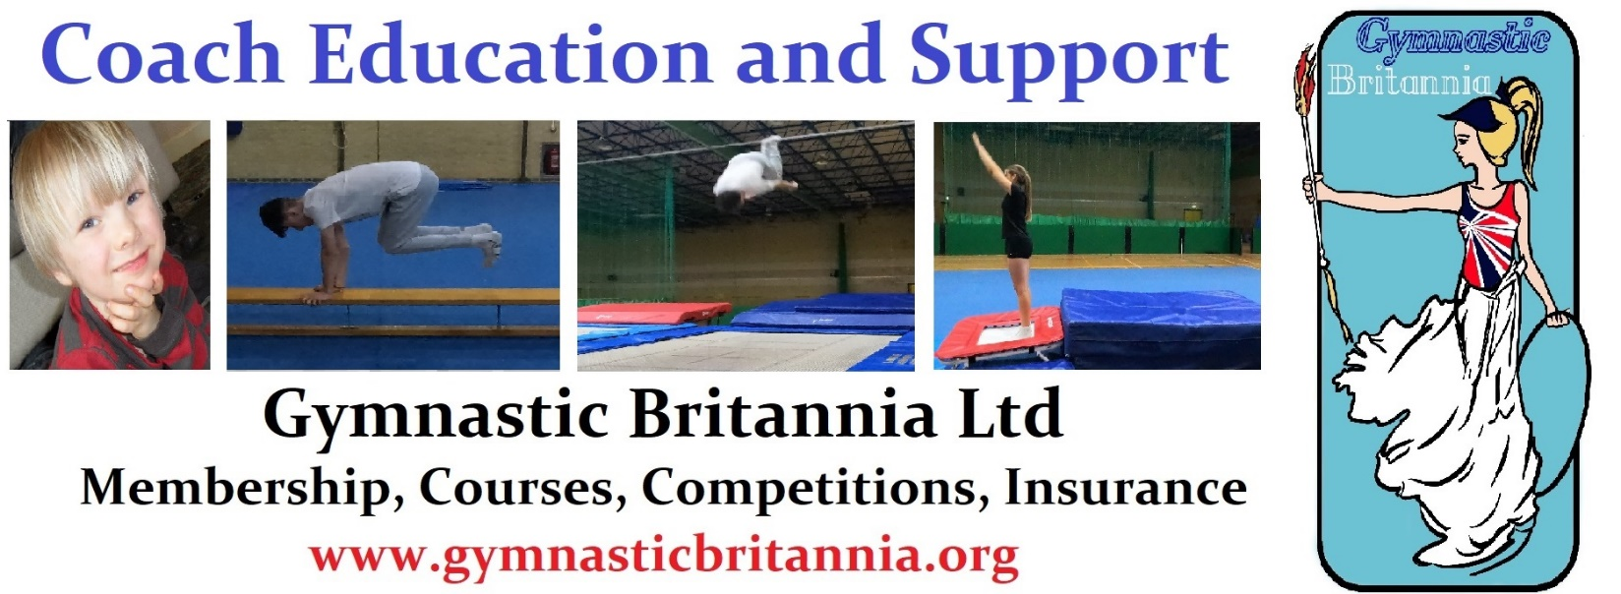

**Our Supporters: -**

**Membership services for Clubs, Coaches and Participants** [**www.gymnasticbritannia.org**](http://www.gymnasticbritannia.org)

**Music for Gymnastics and Cheerleading** [**www.gymjamz.co.uk**](http://www.gymjamz.co.uk)

**Competition Dates: (Prices are per person (or synchro pair) per event)**

|  |  |  |  |
| --- | --- | --- | --- |
| **Event** | **Event Area / Price** | **Entry Form and Fee Dates** | **Submission of Video Dates** |
| **General Gym (Floor and Vault)**  **(SEN)Disability Gym (Floor and Vault)** | National  (£10 per person)  (SEN £10 per person) | 01 – 15 July 2023 | 15 – 20th July 2023 |
| **General Gym (Floor and Vault)**  **(SEN)Disability Gym (Floor and Vault)**  **Synchro Floor & Vault**  **(SEN) Disability Synchro Floor & Vault** | National  (£10 per person)  (SEN £10 per person)  **Synchro £15 Per Pair**  **SEN Synchro £15 Per**  **Pair** | 15 – 25 Nov 2023 | 25th Nov –5th Dec 2023 |
| **General Gym (Floor and Vault)**  **Disability Gym (Floor and Vault)**  **Synchro Floor & Vault**  **Disability Synchro Floor & Vault** | Top 3 from Nationals are eligible for the  International  (£13 per person)  (£21 per synchro) | 10 Jan – 20 Jan 2024 | 20th Jan – 06 Feb 2024 |
| **Trampolining**  **Synchro Trampolining**    **Disability Trampolining**  **Disability Synchro** | National  (£10 per person)  (£18 per synchro)  (£08 Disability)  (£15 per disability synchro) | 15– 25 Nov 2023 | 25th Nov – 5th Dec 2023 |
| **Trampolining**  **Synchro Trampolining**    **Disability Trampolining**  **Disability Synchro** | Top 3 from National are eligible for the  International  Competitions  (£13 per person)  (£21 per synchro)  (£08 Disability)  (£18 per disability synchro) | 10 Jan – 20 Jan 2024 | 20th Jan – 06th Feb 2024 |

** Quality Assurance Scheme for Clubs and Leisure Centres.**

**Visit:** [**winstrada.com/inclusion/gymquest.shtml**](https://winstrada.com/inclusion/gymquest.shtml)

**Page: Menu:**

02 Competition dates / submission dates.

03 Menu / Gymnastic Britannia Advert.

04 – 05 Gymnastics Routines

05 Synchro Gym / Disability Gym Synchro

06 - 07 Disability Gymnastics Routines

**Page: Menu:**

08 Trampolining Routines

09 Trampoline Synchro & Disabilities Synchro

09 Disability Trampolining Routine

9 – 17 Competition Rules

**Looking for an organization made for clubs?**

Look no further we are here for you, Gymnastic Britannia provides insurance plus other membership benefits we specialise in recreational clubs.

**Reasons to be cheerful**

1. Receive Insurance
2. We recognise all Rebound Therapy, AuthoritySportsUK, BG and IGA qualifications, also other qualifications are considered upon request.
3. All Gymnastics Disciplines included plus Aerial Hoops.
4. New Disciplines will be added during the year.
5. Budget Friendly to help clubs in an uncertain economy.
6. Our popular Spaces Membership (Pay for the space not the participant)

For Information E-Mail: [**info@gymnasticbritannia.org**](mailto:info@gymnasticbritannia.org) **www.gymnasticbritannia.org**

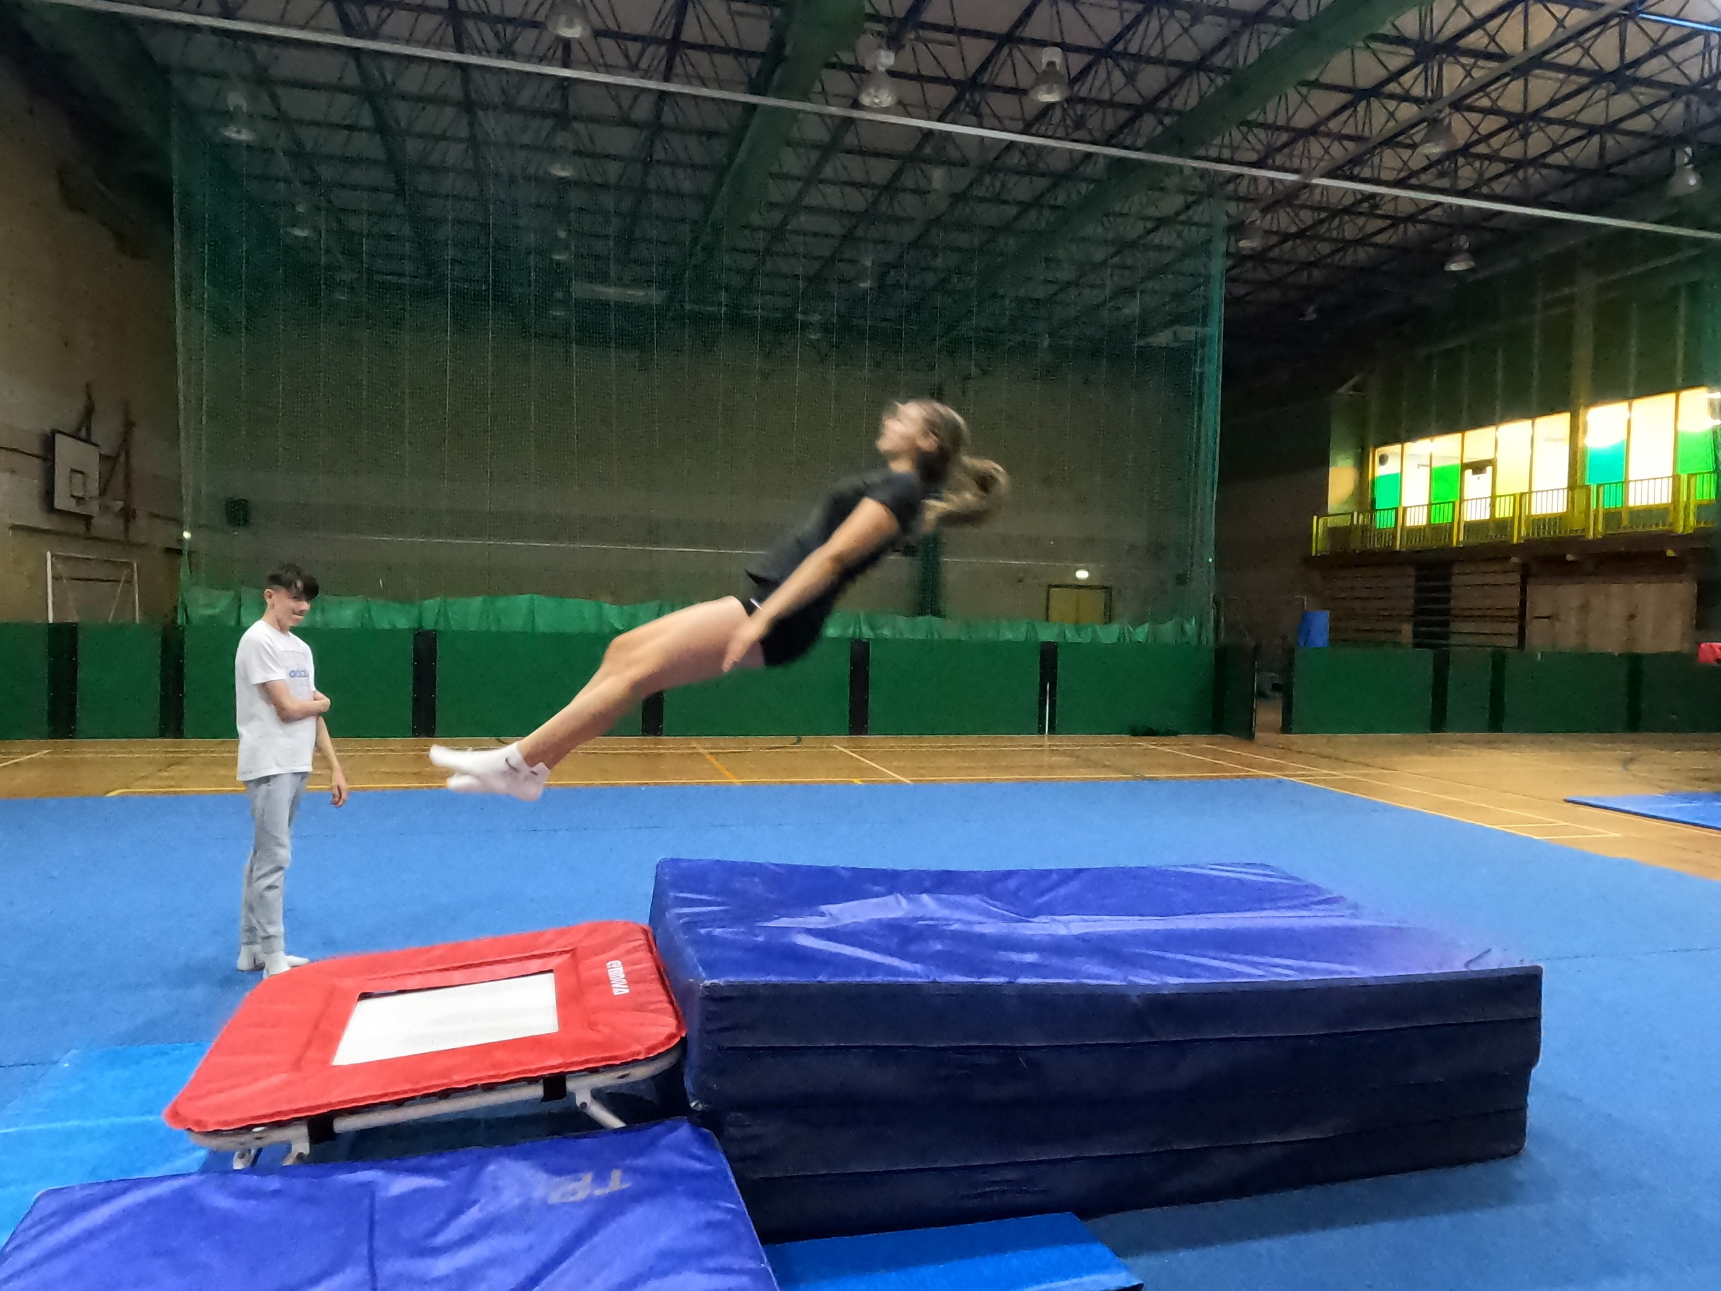](http://www.gymnasticbritannia.org) [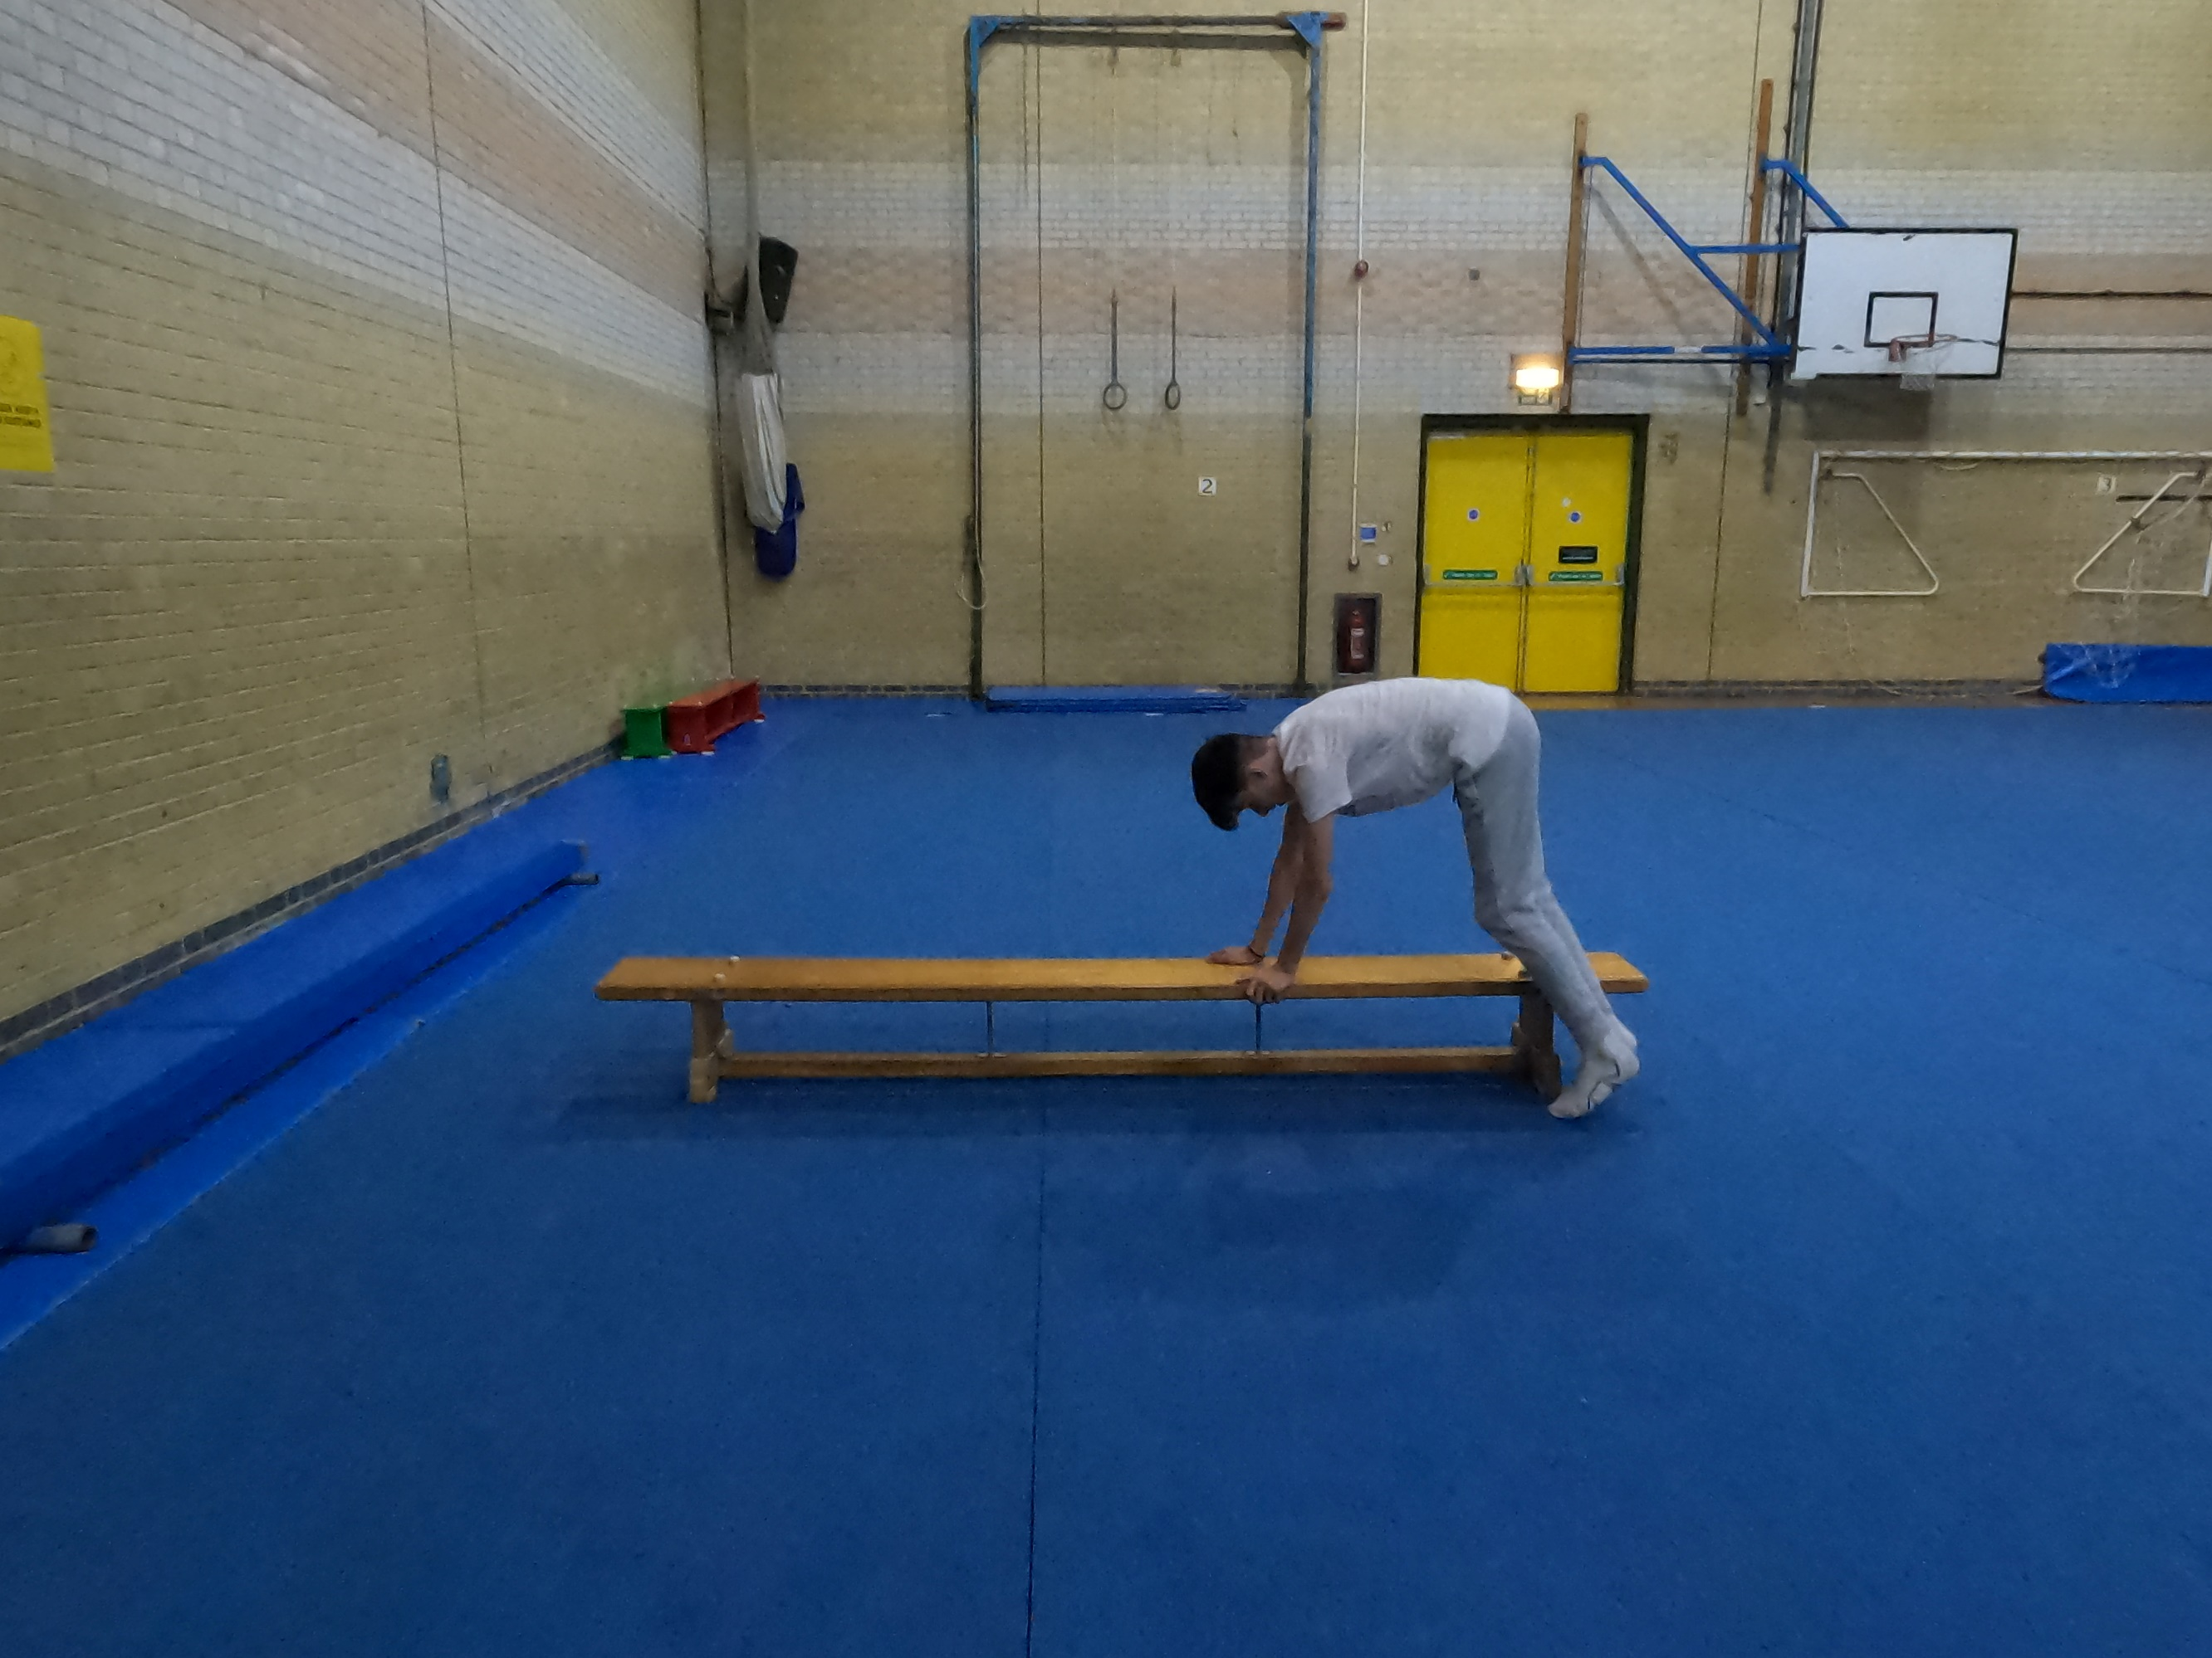](mailto:info@gymnasticbritannia.org?subject=Train%20the%20Trainer)

[**Gymnastic Britannia Ltd**](http://www.gymnasticbritannia.org)

1. **General Gymnastics Floor & Vault (International as below with fees as listed on page 2)**

* **Entry Fees**
* See page 2
* **Age Groups:**
* U7, U9, U10, U11, U12, U13, U15, U18, O18 **(Age based on how old the participant will be in Dec 2023)**
* These will be Split into Male and Female (In case of low numbers we reserve the right to combined)
* **Rules:**

|  |  |  |
| --- | --- | --- |
| **Beginner (Score out of 10 points)** | **Intermediate (Score out of 10 points)** | **Advanced (Score out of 10)** |
| 1. **Half Twist Jump** 2. **Star Jump** 3. **Forward Roll to Straddle Sit** 4. **Teddy Bear Roll (180 or 360)** 5. **Put legs together push into Back Support back to seat.** 6. **Lye on back into Dish** 7. **Roll sideways to Arch Shape** 8. **Push into Front Support jump feet in to hands** 9. **Jump stretch to Feet** 10. **1 leg balance, knee at least 45 degrees (hold 2 sec)** | Make a 10 move routine comprising the following moves in any safe and creative order  **Full Twist Jump, Cartwheel**  **Tuck Jump, Arabesque**  **Forward Roll to Straddle Sit**  **Push legs together Into Back Support**  **Push to Side Support**  **Into Front Support to Squat**  **Jump into Forward Roll to Stand**  **+ 1 move from A** | 1. A routine made up of the following with or without music, 2. **4 moves from A,** 3. **5 Moves from B,** 4. **1 from optional moves**   **Or**   1. With or without music, 2. **4 moves from A,** 3. **4 Moves from B,** 4. **1 from optional moves** 5. **1 Move from C** |
| **Advanced Two (Score out of 10)** | | |
| 1. A routine made up of the following with or without music, **Minimum of 4 moves from C, and any other moves from B and Optional Moves (to make a routine of 10 moves, additional dance work can be added but will not be scored, except for between 0.00-0.5 which will be added for artistry.** | | |

* **Grades Floor:** Additional steps / dance may be used to move from one move to another but only moves will be scored, however additional 0.0-0.5 will be awarded for artistic**.**
* **Moves (Moves in Red updated 31/12/21)**

|  |  |  |  |
| --- | --- | --- | --- |
| **A** | **B** | **C** | **Optional** |
| Shoulder Stand  Scissor Kick  Full Twist  Half Twist  Star Jump  Forward Roll  Backwards Roll  Bridge  Japana | Forward walkover  Backward walkover  Handstand Forward Roll  Backwards Roll to Handstand  Y Balance  Handstand pirouette ½ twist  Cat Leap full Twist  Change Leg Leap  Roundoff  Stag Leap  Pike Lever | Handspring (Front)  Handspring (Back)  Dive Forward Roll  Free Cartwheel  Flyspring  Handstand Pirouette full twist  Straddle Jump Full turn  1 ½ twist Jump  Back Flick  Front Somersault (Tucked)  Back Somersault (Tucked)  Valdez | Arabesque, Handstand, V Sit, Folded Pike, drop to front support, Front or Back support lower and push up, Splits box or sidewards, Bridge Kickover, Backwards roll to front support, Cat leap, Cat leap ½ twist, Tuck, Straddle, Pike, |

* **Grades Vault:**

|  |  |  |  |
| --- | --- | --- | --- |
| **Beginner** | **Intermediate** | **Advanced** | **Advanced Two** |
| 1. **Straight Jump onto a block stretched walk to end, star jump off with safe landing**   **OR**   1. **Straight Jump onto a block then immediate rebound star jump off with safe landing**   **Tariff for either 10.7**  **Block height 60cm** | 1. **Squat on Immediate Straight Jump off**   **OR**   1. **Squat on Immediate Tuck Jump Off**   **Tariff for either 11.2**  **Vault or Table Height100/110 or 120** | 1. **Squat Through**   **OR**   1. **Straddle Over**   **Tariff for either 11.5**  **Vault or Table Height 100/110 or 120** | 1. **Handspring**   **Or**   1. **Headspring**   **Tariff 12.5**  **Vault or Table Height 100/110 or 120** |

1. **NEW - Synchro Gymnastics & Synchro Disabilities Gymnastics (Floor & Vault) - NEW**

* **Entry Fees (National)** (International price is as per page 2)
* As per page 2
* **Number required for Synchro competition**
* A synchro pair is made up of 2 individuals
* **Routines.**
* As per Gymnastics Floor & Vault Routines as page 4/5. (Disability Gymnastics as per Disability Competition Routines page 6)
* **Aim of Competition**
* To have both participants do the same moves at the same time and finish / present at same time
* **Age Groups:**
* U7, U9, U10, U11, U12, U13, U15, U18, O18 **(Age based on how old the participant will be in Dec 2023)**
* These will be Split into Male and Female (In case of low numbers we reserve the right to combined)
* **Rules:**
* **Grades Floor:** Additional steps / dance may be used to move from one move to another but only moves will be scored, however additional 0.0-0.5 will be awarded for artistic**.**

1. **Disability Gymnastics:**

* **Entry Fees**
* As per page 2
* **Age Groups:**
* U7, U9, U10, U11, U12, U13, U15, U18, O18 **(Age based on how old the participant will be in Dec 2023)**
* These will be Split into Male and Female (In case of low numbers we reserve the right to combined)

**Routines Disability Gymnastics (Made up of 1 Floor Routine & 1 Vault)**

|  |  |  |
| --- | --- | --- |
| **Grade 3**  Star Shape on feet into stretch straight shape into ¼ turn move  Or  Lying straight flat on back into star shape on back then roll onto tummy. | **Grade 4**  Star Shape on feet into stretch straight shape into ¼ turn move then balance on 1 foot.  Or  Lying straight flat on back into star shape on back then roll onto tummy show arch shape. | **Grade 5**  Balance on one foot then the other, sit on floor; show tuck, then pike then straddle position  Or  Lying straight flat on back into star shape on back then roll onto tummy show arch roll to dish then into sitting position. |
| **Grade 6**  Stand with good posture, Star jump x 2, Astride jump x 2, half twist jump, drop to squat, jump feet back to front support  Or  Stand with good posture, star jump, astride jump, star jump, astride jump, half twist jump, drop to squat, jump feet back to front support. | **Grade 7**  Stand with good posture, Star jump x 2, Astride jump x 2, half twist jump, half twist jump, drop to squat, jump feet back to front support Lower to lye stretched on floor.  Or  Stand with good posture, Star jump, Astride jump, half twist jump, Star jump, Astride jump, half twist jump, drop to squat, jump feet back to front support Lower to lye stretched on floor. | **Grade 8**  Stand with good posture, Forward roll to stand, Star Jump, half twist, Star jump, Drop into Squat, Jump feet back to front support, push to side support, to back support, lye into dish then roll to arch.  Or  Stand with good posture, Backward roll to stand, Star Jump, half twist, Star jump, Drop into Squat, Jump feet back to front support, push to side support, to back support, lye into dish then roll to arch. |

**Grades 3 to 8; no physical assistance but verbal prompting, signing and mirroring permitted**

**Vault Gradings: The competition is made up of 1 floor routine and 1 Vault,**

|  |  |
| --- | --- |
| **Grade 3 (Light Support if required)** | **Grade 4 (Light Support if required)** |
| 1. **Straight Jump onto a block stretched walk to end, star jump off with safe landing**   **Tariff 10.7**  **Block or firm safety mats**  **height approx. 60cm** | 1. **Squat on Straight Jump off**   **OR**   1. **Straddle on Straight Jump Off**   **Tariff for either 11.2**  **Block or firm safety mats**  **height approx. 60cm** |

|  |  |  |  |
| --- | --- | --- | --- |
| **Grade 5** | **Grade 6** | **Grade 7** | **Grade 8** |
| 1. **Straight Jump onto a block stretched walk to end, star jump off with safe landing**   **OR**   1. **Straight Jump onto a block then immediate rebound star jump off with safe landing**   **Tariff for either 10.7**  **Block or firm safety mats**  **height approx. 60cm** | 1. **Squat on Immediate Straight Jump off**   **OR**   1. **Squat on Immediate Tuck Jump Off**   **Tariff for either 11.2**  **Vault or Table Height100/110 or 120** | 1. **Squat on Immediate ½ Twist Jump off**   **OR**   1. **Straddle on Immediate ½ Twist Jump Off**   **Tariff for either 11.3**  **Vault or Table Height 100/110 or 120** | 1. **Squat Through**   **OR**   1. **Straddle Over**   **Tariff 11.5**  **Vault or Table Height 100/110 or 120** |

1. **Trampolining:**

* **Entry fees**
* See page 2
* **Age Groups**
* U9, U11, U13, U15, U18, O18 **(Age based on how old the participant will be in Dec 2023)**
* These will be Split into Male, Female (In case of low numbers we reserve the right to combine)

**Competition Made up of 1 Set Routine, and 1 Voluntary Routine**

* **Routines: SET**

**Beginner Intermediate (Choice 1) Intermediate (Choice 2)**

* **1. Seat Landing Full Twist Back Somersault (T)**
* **2. To Feet Straddle Straddle**
* **3. Half Twist Seat Landing Seat Landing**
* **4. Straddle ½ Twist to Seat Landing ½ Twist to Seat Landing**
* **5. Full Twist ½ Twist to Feet ½ Twist to Feet**
* **6. Pike Pike Pike**
* **7. Half Twist Back Landing Back Landing**
* **8. Tuck ½ Twist ½ Twist to Feet**
* **9. Seat Landing Tuck Tuck**
* **10. Half Twist to Feet Front Somersault (T) Full Twist**

**Voluntary Routine** Max 1.2 (No Tariff Awarded) Max Tariff 1.6 Max Tariff: 1.6

Max SS Rotation 270 degrees Somersaults with half twists

**Advanced (Choice 1) Advanced (Choice 2) Advanced 2**

**Make a routine up which must comprise of 6 skills of minimum 360 degrees rotation, 2 skills with minimum of 360 rotation and 180 degrees twist, 2 additional skills of your choosing**

* **1. Back Somersault (T) Back Somersault (T)**
* **2. Straddle Straddle**
* **3. Full Twist Back Somersault (T) to Seat**
* **4. Tuck ½ Twist to Feet**
* **5. Barani (T) ½ Twist**
* **6. Pike Pike**
* **7. ½ twist to Back Landing Back Landing**
* **8. ½ Twist to Feet ½ Twist to Feet**
* **9. Pike Tuck**
* **10. Front Somersault (P) Barani (T)**

**Voluntary Routine** Max Tariff 3.0 Max Tariff 3.0 Max Tariff: 10.0

1. **Synchro Trampolining / Disabilities Synchro:**

* **Entry fees**
* See page 2
* **Routine**
* Routines as per Trampoline event / Disability as per Disability Trampoline Routines
* **Age Groups**
* Age Groups as per Trampoline
* Submission of 1 Set and 1 Voluntary routine.

1. **Special Needs Trampoline Competition Routines**

* **Entry Fees**
* See page 2
* **Age Groups**
* Age Groups as per Trampoline (Submission of 1 Set and 1 Voluntary Routine)

**Scoring and Judging notes – Grades 3 to 8**

|  |  |  |
| --- | --- | --- |
| **Grade 3**  Tuck jump, 1/2 twist jump, Star position | **Grade 4**  Seat drop, to feet, Tuck jump, 1/2 twist jump | **Grade 5**  Star jump, Seat drop, to feet, Tuck jump, 1/2 twist jump, Straight jump |
| **Grade 6**  Straddle jump, Seat drop, to feet, Tuck jump, 1/2 twist jump, Pike jump, Seat drop 1/2 twist, to feet, Straight jump, | **Grade 7**  Front drop, to feet, Tuck jump, 1/2 twist jump, Straddle jump, Seat drop, to feet, Pike jump, Full twist jump, Straight jump, | **Grade 8**  Front drop, to feet, Straddle jump, 1/2 twist jump,  Seat drop, 1/2/ twist to seat drop, 1/2 twist to feet, Tuck jump, Pike jump, Full twist jump, |

1. **Grades 3 to 8; no physical assistance but verbal prompting,**
2. **signing and mirroring permitted**
3. **Competition Rules common to all events.**

* Everyone is advised to read the information contained, any queries should be directed via our website.
* If something specific has been omitted then the chair of judges, and / or the competition organiser shall rectify and give a score or make a decision based on using fairness for all involved.
* All videos submitted must be in line with video requirements
* All judging will be carried out by independent ASUK Virtual Competition Judges who will be qualified via a Governing Body or where no specific judging qualification is available, there will be a selection of judges trained specifically for the discipline by AuthoritySportsUK Competition organiser and in line with our rules. So therefore, I am pleased to say you do not have to supply judges.
* All entries will be accepted for participants who are coached by a qualified coach / instructor / teacher and have insurance to do so, routines must be carried out in a safe sporting environment, and under the direct supervision of a qualified person.
* Videos must be uploaded by the closing date any late entries will be rejected unless you receive prior written agreement from the competition organiser.
* Once all entries have been received, it is aimed that all results will be released within 2 weeks after closing date, however we aim for this to be done a lot quicker where possible.
* All rules are required to be adhered to otherwise a score may not be given.

1. **Filming Guidance for all disciplines.**

* Clubs, coaches and organisations submitting videos of routines must ensure that they have written permission for having their image used and potentially published, from the guardian of the participant for under 18’s, over 18’s classified as vulnerable adults. For over 18’s permission from the performer. This must be done for anyone who is shown within the video including coaches or relevant persons.

* AuthoritySportsUK, Gymnastic Britannia or any associated organisations **cannot** be held responsible or liable for any misuse of image rights or any financial claims that arise thereof.
* To ensure best potential quality for filming, you can use **Camera**, **Smart Phones**, or **Tablets** but ensure the routine can be seen clearly to ensure they can be judged.

* The filming should be done in **Landscape** to ensure maximum visibility and appropriate distance away from the routine so that the whole performance area can be seen adequately including the full performers skills. The Recording device should ideally be on a stand or tripod to ensure stability and should not be moved side to side or up and down.
* To ensure that the performers can be seen adequately please ensure it is evenly lit.
* Details should be shown on a card at beginning prior to commencement of performance.
* Each video should be labelled with Competitors name and if it is set or vol (TR), or Floor or Vault (GG).
* During filming there should be no verbal instructions from coach (unless stated otherwise), and any music must be within requirements and in line with regulations, avoiding Andrew Lloyd Webber, Disney Music.
* All filming should be clear without blurring, any routines or displays that are blurred may not be judged, this will be down to the chair of judges to decide if it can be judged fairly and within rules.
* Anyone competing must compete using adequate matting and on equipment deemed to be safe.

1. **General Video Guidance.**

* At the start of the video the registration symbol must be used which is unique to your club and discipline specific, in addition each routine should have full name written on a white background paper or whiteboard. (to receive the registration symbols we require the registration form with full payment.)
* Filming of routines / displays, may only be done after receiving your registration symbol, and the showing the name and symbol must be done within the video whilst recording and not edited in later on, in one continuous recording.
* Each event type will have a different symbol associated.
* At start and end of the routine / display there should be a **Presentation to camera** (otherwise points may be deducted.)
* See Discipline specific sections for any adjustments required for filming and these must be complied with.
* All routines or displays must be complete.

1. **Fees**

* Each discipline will show the allocated entry fees.

1. **Top 3 of each group.**

* The top 3 or each group will receive a trophy (Medals for Disability Events), all other entries will receive a certificate of participation with their placing upon it.
* Subject to competition team medals may be applicable.

1. **Exceptional Circumstances (Regions)**

* Where a age group or discipline does not have enough entries, we reserve the right to combine them with another region to make a group.

1. **Disciplines**

* **Trampolining**
* **Disability Trampolining**
* **Trampoline Synchro**
* **SEN Trampoline Synchro**
* **General Gymnastics Floor & Vault**
* **Synchro Gymnastics Floor & Vault**
* **Disability Gymnastics Floor & Vault**
* **SEN Synchro Gymnastics Floor & Vault**

1. **Trampolining (International as below with fees as listed on page 2)**

* **Specific Rules**
* Execution deductions will be taken off per skill 0.0-0.05, we are basing scores on execution only we shall not be recording **horizontal displacement (HD)** or **time of flight (TOF)** scores.
* In the set routine missing a skill will mean the routine will stop being judged at the last set skill performed
* Instability at end of routine 0.1-0.2
* Not **Presenting** at **beginning** or **end** 0.1 deduction
* The 5 execution judges will have highest and lowest score removed, and middle 3 added together. For voluntary routines that are specified tariff will be added on as normal
* Tiebreak, if 2 people within the top 3 receive the same scores, we shall introduce the average of the highest and lowest score which is normally deducted.
* **Competition Attire**
* Male / Female gymnasts
* leotard or unitard with or without sleeves
* Gym shorts or trousers
* White trampoline shoes and/or foot covering or of the same colour as the gym trousers
* For reasons of safety, covering the face is not **permitted**.
* Trampoline shoes and/or white foot covering
* The wearing of jewellery or watches is not permitted during the competition video.
* Rings without gemstones may be worn if they are taped.
* Bandages or support pieces must not create a big contrast with the skin colour.
* Underwear must not be visible.

1. **Trampoline Synchro**

* **Rules**
* Execution deductions will be taken off per skill 0.0-0.05, we are basing scores on execution only we shall not be recording **horizontal displacement (HD)** or **time of flight (TOF)** scores.
* In the set routine missing a skill will mean the routine will stop been judged at the last set skill performed
* Instability at end of routine 0.1-0.2
* Not Presenting at beginning or end 0.1 deduction

* The 6 execution judges will have highest and lowest score removed, and middle 4 added together (2 judging bed 1, 2 judging bed 2). For voluntary routines that are specified tariff will be added on as normal
* Tiebreak, if 2 Synchro Partners within the top 3 receive the same scores, we shall introduce the average of the highest and lowest score which is normally deducted.
* Any rules that may not be covered will comply with FIG code of Points
* Routine as per Trampoline
* Attire as per Trampoline
* Age groups as per trampoline

1. **Disability Trampolining (celebration of participation) (International as below with fees as listed on page 2)**

* Rules as below using Rebound Therapy Competition Scheme.
* Attire as per Trampoline, however if require T-shirt (not baggy) can be tucked into white shorts and wearing white socks.
* Age groups as per trampoline

**‘ReboundTherapy.org’ SEN Trampolining competition framework**

* The competition will have six grades; 3 to 8. The competition routines are shown below (Grades 1-2 are not included as these are for in person events only)
* Grades 3+ No physical assistance permitted. Verbal prompting, signing and mirroring is permitted for all grades.
* All participants / competitors will have 2 performance routines submitted (even if they are the same)
* The first performance for Grades 3+ will be a compulsory routine. (Routines shown below).
* The second performance for grades 3, 4 and 5 should be a repeat of the first routine.
* The second performance for grades 6, 7 and 8 is a voluntary; it can be a repeat of the first routine or any other routine made up of exercises from the Winstrada scheme, but must not include exercises from a higher grade than that which the student is entering at. ([Click here](http://www.reboundtherapy.org/rsc/comps/grades_6_7_and_8_exercises.doc) for Grades 6, 7 and 8 **exercise** list.) The routine should comprise nine contacts for grade 6 and ten contacts for grades 7 and 8.

**Scoring and Judging notes – Grades 3 to 8**

All routines for grades 3 and above will have a maximum possible score of 10. They will be marked out of the number of contacts in the routine, then the appropriate number will be added to enable the routine to show a score out of 10, as follows:

* Grade 3 comprises three contacts so will be scored out of 3 and 7 will be added to the form score to bring it up to 10
* Grade 4 comprises four contacts so will be scored out of 4 and 6 will be added.
* Grade 5 comprises six contacts so will be scored out of 6 and 4 will be added.
* Grade 6 comprises nine contacts so will be scored out of 9 and 1 will be added.
* Grades 7 and 8 have ten contacts in the routines so nothing will be added.

Scoring deductions are made as follows:

* Faults: 0.1 to 0.5
* Final ‘landing’ faults – Grades 6, 7 and 8 only: 0.1 to 0.2 for instability
* A missing move in the compulsory (1st routine) will end the routine at that point
* Grades 3, 4 and 5 - No deductions will be made for extra bounces, whether during or after the routine
* Grades 6, 7 and 8 – 0.1 deductions will be made for each extra bounce during the routine.

Other notes:

* All grades – students should attempt to stop and remain in stillness before dismounting
* Grades 4, 7 and 8 – the first move does not necessarily have to start from a standing position
* There will be no tariff (difficulty) scores.
* An optional out bounce is permitted at the end of the routine.
* The routine is deemed to have started once the first skill has been performed, however a maximum of three false starts without penalty will be allowed.



**Courses available for**

* Gymnastics
* Pre-school Gymnastics
* Trampolining and Rebound therapy

visit [Authoritysportsuk](https://www.authoritysportsuk.co.uk/courses)

* The routine is deemed to have finished after the last skill plus one out-bounce.
* Competition organisers may, if they wish, decide to award a bonus mark if the routine is performed without any assistance.
* Where there are a number of competitors in medal winning places with the same score, the senior judge should decide the placing based on his / her scoresheet. When that is not possible, the number of extra bounces in the routine should be taken into account.

**Medals will be awarded for 1st, 2nd and 3rd places in each category, subject to sufficient number of entrants. It is suggested that if there are only four entrants in a category for example, then medals should only be awarded for 1st and 2nd places, as there should never be just one competitor left without a medal. Certificates will be awarded to all competitors.**

* **Gymnastics (Floor and vault) Rules**
* **8 by 8-meter floor or 12 by 12-meter floor area is preferred but a strip of flooring can also be used.**
* **Gymnast must partake in the correct competition beginner, intermediate, advanced or advanced two at the highest level they are able to do safely (i.e., if they are able to do the Advanced safely but can do the Intermediate easily and can only sometimes perform the advanced two vault and routines safely, they should do the advanced competition).**
* **Common rules as per set out in parts 1-6.**
* **Execution deductions for Vault and floor between 0.0 and 0.5**
* **Tiebreak if 2 competitors within the top 3 receive identical placings, the floor scores will be used as a decider for placings.**
* **Competition Attire**
* Male / Female gymnasts
* leotard or unitard with or without sleeves
* Gym shorts or trousers
* For reasons of safety, covering the face is not permitted.

* The wearing of jewellery or watches is not permitted during the competition video.   Rings without gemstones may be worn if they are taped.

****Bandages or support pieces must not create a big contrast with the skin colour. Underwear must not be visible.

**Winstrada Proficiency Awards**

Trampolining

Gymnastics Scheme

**New - Pre-school and Disabilities Awards - New**

Pre-school, Disabilities and Recreational.

**Free Resources to view and download**

[**Visit for more information Click Here**](https://www.authoritysportsuk.co.uk/proficency-awards)

1. **Synchornised Gymnastics (Floor & Vault) & Disability Synchronised (Floor & Vault)**

* Rules as per Gymnastics (Floor & Vault) and Disability Gymnastics
* Both participants should do Routine / Vault (Side by Side) together at the same time
* There will be 2 judges judging competitor 1, 2 judges judging competitor 2 and 1 judge judging Synchro.

1. **Disability Gymnastics (These rules are based on Winstrada Awards Scheme and Rebound Therapy Scheme)**

* The competition will have six grades; 3 to 8. The competition routines are shown below (Grades 1-2 are not included as these are for in person events only)
* **Grade 3** Minimal Physical Assistance may be given. **Grades 4+** No physical assistance permitted. Verbal prompting, signing and mirroring is permitted for all grades.
* All participants / competitors will have 1 floor routine and 1 Block / Vault Pass
* The Floor routine will be set as below however there will be a choice of 2 routines to choose from to allow those who may have issues with certain moves to still partake,

**Vault Gradings: The competition is made up of 1 floor routine and 1 Vault,**

All routines for grades 3 and above will have a maximum possible score of 10. They will be marked out of the number of skills, then the appropriate number will be added to enable the routine to show a score out of 10, as follows:

* Grade 3 comprises three moves so will be scored out of 3 and 7 will be added to the form score to bring it up to 10
* Grade 4 comprises four moves so will be scored out of 4 and 6 will be added.
* Grade 5 comprises six moves so will be scored out of 6 and 4 will be added.
* Grade 6 comprises eight moves so will be scored out of 8 and 2 will be added.
* Grade 7 comprises nine moves so will be scored out of 9 and 1 will be added.
* Grades 8 have ten moves in the routines so nothing will be added.

Scoring deductions are made as follows:

* Execution Faults: 0.1 to 0.5
* Final ‘landing’ faults – Grades 6, 7 and 8 only: 0.1 to 0.2 for instability
* A missing move in the compulsory floor (routine) will end the routine at that point.
* Grades 3, 4 and 5 - No deductions will be made for extra steps, whether during or after the routine
* Grades 6, 7 and 8 – 0.1 deductions will be made for each extra step/s during the routine.

Other notes:

* All grades – students should attempt to present at beginning and end of routine (where possible)
* Grades 4, 7 and 8 – the first move does not necessarily have to start from a standing position
* There will be no tariff (difficulty) scores.
* The routine is deemed to have started once the first skill has been performed, however a maximum of three false starts without penalty will be allowed.
* The routine is deemed to have finished after the last skill.
* Competition organisers may, if they wish, decide to award a bonus mark if the routine is performed without any assistance.
* Where there are a number of competitors in medal winning places with the same score, the senior judge should decide the placing based on his / her scoresheet. When that is not possible, the number of extra steps in the routine should be taken into account.

Medals will be awarded for 1st, 2nd and 3rd places in each category, subject to sufficient number of entrants. It is suggested that if there are only four entrants in a category for example, then medals should only be awarded for 1st and 2nd places, as there should never be just one competitor left without a medal.

Certificates will be awarded to all competitors.

**Entry Forms will be on** [**www.authoritysportsuk.co.uk**](http://www.authoritysportsuk.co.uk) **website to complete, these will be published a minimum of 7 days before entry date opens.**